

Undergraduate/Graduate1 Programme

Major __________   
Minor2 _______________

Oleksandr Romanchenko Student number: 83459

Deep Reinforcement Learning: training intelligent agent to play game “Flappy Bird” with evolution strategy algorithm

Bachelor's/Master's1 thesis written in the Department/lnstitute1  
____________________________________________

under scientific supervision of  
_____________________________

Warsaw 2019

1. Apply as appropriate
2. If no major has been selected or no declaration of the major has been filed, skip the entry.

Topic: Deep Reinforcement Learning: training intelligent agent to play “Flappy Bird” with evolution strategy algorithm

sources:

<https://towardsdatascience.com/introduction-to-machine-learning-for-beginners-eed6024fdb08>

<https://blog.soshace.com/deep-learning-vs-machine-learning-overview-comparison/>

**Introduction to Machine Learning**

We have seen Machine Learning as a buzzword for the past few years, the reason for this might be the high amount of data production by applications, the increase of computation power in the past few years and the development of better algorithms.

Machine Learning is used anywhere from automating mundane tasks to offering intelligent insights, industries in every sector try to benefit from it. We are already using devices that utilizes it. For example, a wearable fitness tracker like Fitbit, or an intelligent home assistant like Google Home. But there are much more examples of ML in use.

* Prediction — Machine learning can also be used in the prediction systems. Considering the loan example, to compute the probability of a fault, the system will need to classify the available data in groups.
* Image recognition — Machine learning can be used for face detection in an image as well. There is a separate category for each person in a database of several people.
* Speech Recognition — It is the translation of spoken words into the text. It is used in voice searches and more. Voice user interfaces include voice dialing, call routing, and appliance control. It can also be used a simple data entry and the preparation of structured documents.
* Medical diagnoses — ML is trained to recognize cancerous tissues.
* Financial industry and trading — companies use ML in fraud investigations and credit checks.

**A Quick History of Machine Learning**

Image: Linked In | Machine Learning vs Deep learning

It was in the 1940s when the first manually operated computer system, ENIAC (Electronic Numerical Integrator and Computer), was invented. At that time the word “computer” was being used as a name for a human with intensive numerical computation capabilities, so, ENIAC was called a numerical computing machine! Well, you may say it has nothing to do with learning?! WRONG, from the beginning the idea was to build a machine able to emulate human thinking and learning.

EIMC — Electronic Numerical Integrator and Computer | Image: www.computerhistory.org

In the 1950s, we see the first computer game program claiming to be able to beat the checkers world champion. This program helped checkers players a lot in improving their skills! Around the same time, Frank Rosenblatt invented the Perceptron, which was a very, very simple classifier but when it was combined in large numbers, in a network, it became a powerful monster. Well, the monster is relative to the time and in that time, it was a real breakthrough. Then we see several years of stagnation of the neural network field due to its difficulties in solving certain problems.

Thanks to statistics, machine learning became very famous in the 1990s. The intersection of computer science and statistics gave birth to probabilistic approaches in AI. This shifted the field further toward data-driven approaches. Having large-scale data available, scientists started to build intelligent systems that were able to analyze and learn from large amounts of data. As a highlight, IBM’s Deep Blue system beat the world champion of chess, the grand-master Garry Kasparov. Kasparov accused IBM of cheating, but this is a piece of history now and Deep Blue is resting peacefully in a museum.

**What is Machine Learning?**

According to Arthur Samuel, Machine Learning algorithms enable the computers to learn from data, and even improve themselves, without being explicitly programmed.

Machine learning (ML) is a category of an algorithm that allows software applications to become more accurate in predicting outcomes without being explicitly programmed. The basic premise of machine learning is to build algorithms that can receive input data and use statistical analysis to predict an output while updating outputs as new data becomes available.

**Types of Machine Learning?**

Machine learning can be classified into 3 types of algorithms.

1. Supervised Learning
2. Unsupervised Learning
3. Reinforcement Learning

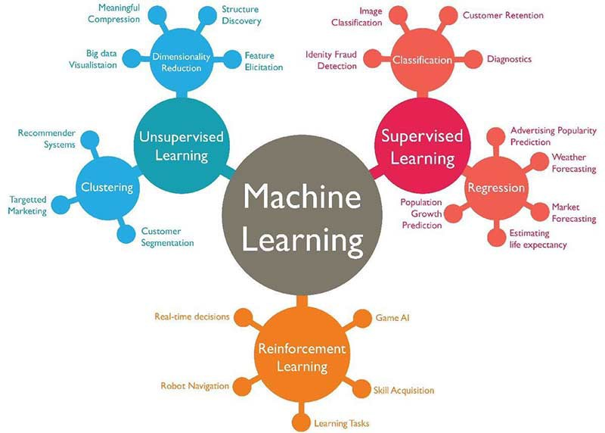

3 Types of Learning

**Overview of Supervised Learning Algorithm**

In Supervised learning, an AI system is presented with data which is labeled, which means that each data tagged with the correct label.

The goal is to approximate the mapping function so well that when you have new input data (x) that you can predict the output variables (Y) for that data.

Example of Supervised Learning

As shown in the above example, we have initially taken some data and marked them as ‘Spam’ or ‘Not Spam’. This labeled data is used by the training supervised model, this data is used to train the model.

Once it is trained, we can test our model by testing it with some test new mails and checking of the model is able to predict the right output.

**Types of Supervised learning**

* **Classification**: A classification problem is when the output variable is a category, such as “red” or “blue” or “disease” and “no disease”.
* **Regression**: A regression problem is when the output variable is a real value, such as “dollars” or “weight”.

**Overview of Unsupervised Learning Algorithm**

In unsupervised learning, an AI system is presented with unlabeled, uncategorized data and the system’s algorithms act on the data without prior training. The output is dependent upon the coded algorithms. Subjecting a system to unsupervised learning is one way of testing AI.

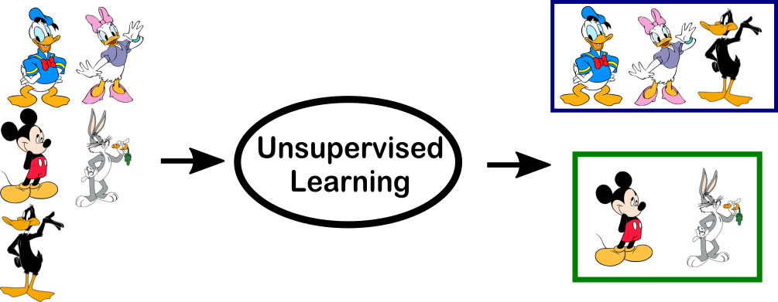

Example of Unsupervised Learning

In the above example, we have given some characters to our model which are ‘Ducks’ and ‘Not Ducks’. In our training data, we don’t provide any label to the corresponding data. The unsupervised model is able to separate both the characters by looking at the type of data and models the underlying structure or distribution in the data in order to learn more about it.

**Types of Unsupervised learning**

* **Clustering**: A clustering problem is where you want to discover the inherent groupings in the data, such as grouping customers by purchasing behavior.
* **Association**: An association rule learning problem is where you want to discover rules that describe large portions of your data, such as people that buy X also tend to buy Y.

**Overview of Reinforcement Learning**

A reinforcement learning algorithm, or agent, learns by interacting with its environment. The agent receives rewards by performing correctly and penalties for performing incorrectly. The agent learns without intervention from a human by maximizing its reward and minimizing its penalty. It is a type of dynamic programming that trains algorithms using a system of reward and punishment.

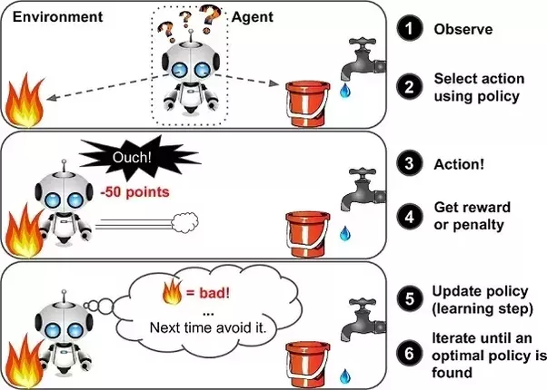

Example of Reinforcement Learning

In the above example, we can see that the agent is given 2 options i.e. a path with water or a path with fire. A reinforcement algorithm works on reward a system i.e. if the agent uses the fire path then the rewards are subtracted, and agent tries to learn that it should avoid the fire path. If it had chosen the water path or the safe path then some points would have been added to the reward points, the agent then would try to learn what path is safe and what path isn’t.

It is basically leveraging the rewards obtained, the agent improves its environment knowledge to select the next action.

## What is deep learning?

Deep learning, on the other hand, is a subset of machine learning, which is inspired by the information processing patterns found in the human brain. The brain deciphers the information, labels it, and assigns it into different categories. When confronted with new information, the brain compares it with the existing information and arrives at the conclusion that spurs future action based on this analysis. Deep learning is based on numerous layers of algorithms (artificial neural networks) each providing a different interpretation of the data that’s been fed to them.

### **How does deep learning work?**

Before we tackle the question of “how it works,” let’s briefly define a few other necessary terms.

Supervised learning is using labeled data sets that have inputs and expected outputs. Unsupervised learning is using data sets with no specified structure.

In the case of supervised learning, a user is expected to train the AI to make the right decision: the user gives the machine the input and the expected output, if the output of AI is wrong, it will readjust its calculations; the iterative process goes on until the AI makes no more mistakes. Among the popular supervised algorithms are linear regression, logistic regression, decision trees, support vector machines, and non-parametric models such as k-Nearest Neighbors. In the case of unsupervised learning, the user lets the AI make logical classifications from the data. Here, algorithms such as hierarchical clustering, k-Means, Gaussian mixture models attempt to learn meaningful structures in the data.

Deep Learning operates without strict rules as the ML algorithms should extract the trends and patterns from the vast sets of unstructured data after accomplishing the process of either supervised or unsupervised learning. To proceed further, we’ll need to define neural networks.

### **Deep Learning vs Neural Network**

The Deep Learning underlying algorithm is neural networks — the more layers, the deeper the network. A layer consists of computational nodes, “neurons,” every one of which connects to all of the neurons in the underlying layer. There are three types of layers:

* The input layer of nodes, which receive information and transfers it to the underlying nodes
* Hidden node layers are the ones which take all calculations
* Output node layer is a place for computational results

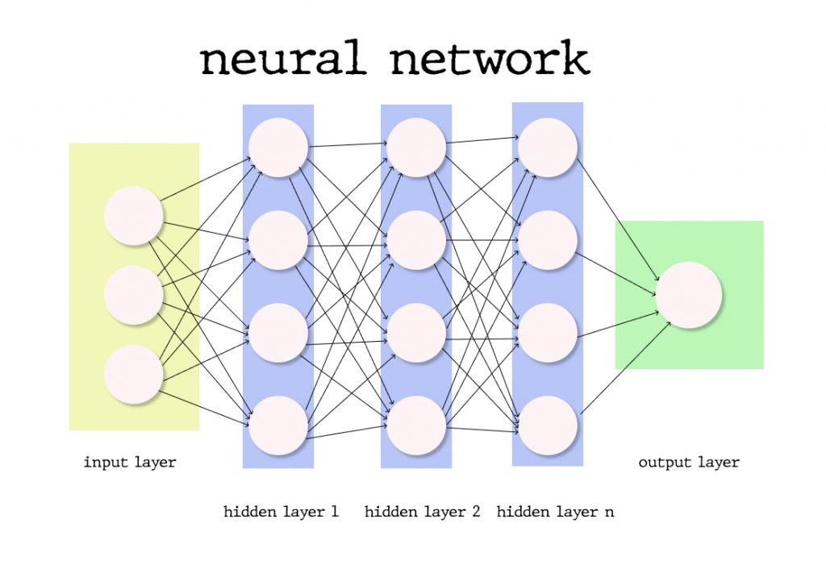

Neural Network

By adding more hidden layers into the network, the researchers enable more in-depth calculations; however, the more layers — the more computational power is needed to deploy such a network.

Each connection has its weight and importance, the initial values of which are assigned randomly or according to their perceived importance for the ML model training dataset creator. The activation function for every neuron evaluates the way the signal should be taken, and if the data analyzed differs from the expected, the weight values are configured anew, and the iteration begins. The difference between the yielded results and the expected is called the loss function, which we need to be as close to zero as possible. Gradient Descent is a function that describes how changing connection importance affects output accuracy. After each iteration, we adjust the weights of the nodes in small increments and find out the direction to reach the set minimum. After several of said iterations, the trained Deep Learning model is expected to produce relatively accurate results and can be deployed to production, however, some tweaking and adjustments can be necessary if the weight of the factors change over time.

### **Deep learning Learning Overview: summary of how DL works**

Deep Learning is one of the ways of implementing Machine Learning through artificial neural networks, algorithms that mimic the structure of the human brain. Basically, DL algorithms use multiple layers to progressively extract higher-level features from the raw input. In DL, each level learns to transform its input data into more abstract representation, more importantly, a deep learning process can learn which features to optimally place in which level on its own, without human interaction. DL is both applicable for supervised and unsupervised learning tasks, where for supervised tasks DL methods eliminate feature engineering and derive layered structures that remove redundancy in representation; DL structures that can be used in an unsupervised manner are deep belief networks and neural history compressors.

### **Deep Learning Applications**

Now, let’s look at some of the top applications of deep learning, which will help you better understand DL and how it works, besides some of those offer fantastic tutorials and source code detailing how to implement those algorithms.

The most well-known application of deep learning is a recommendation engine that’s supposed to enhance the user experience and provide a better service to its users. There are two types of recommendation engines: content-based and collaborative filtering. Until you have a sizable user-base, it’s best recommended to start with the content-based engine first.

Natural Language Processing and Recurrent Neural Networks are used in the text to extract higher level information, also known as text sentiment analysis.

Another popular application is chatbots that can be trained with samples of dialogs and recurrent neural networks

Another popular application of DL models is image retrieval and classification using recognition models to sort images into different categories or using auto-encoders to retrieve images based on visual similarity.

## Machine Learning vs Deep Learning: comparison

One of the most important differences is in the scalability of deep learning versus older machine learning algorithms: when data is small, deep learning doesn’t perform well, but as the amount of data increases, deep learning skyrockets in understanding and performing on that data; conversely, traditional algorithms don’t depend on the amount of data as much.

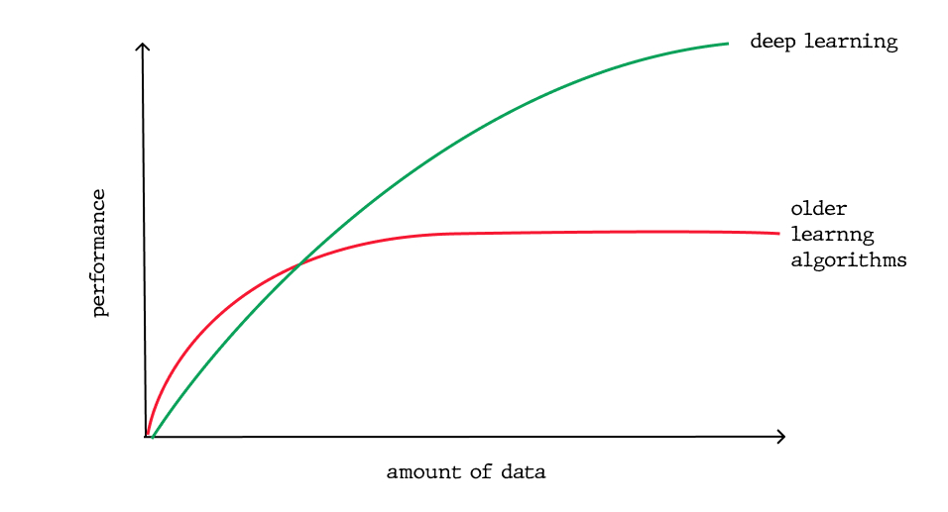

Scaling with Amount of Data

Another important distinction which ensues directly from the first difference is the deep learning hardware dependency: Dl algorithms depend on high-end machines and GPUs, because they do a large amount of matrix multiplication operations, whereas older machine learning algorithms can work on low-end machines perfectly well.

In machine learning, most of the applied features need to be identified by a machine learning expert, who then hand-copies them as per domain and data type. The input values (or features) can be anything from pixel values, shapes, textures, etc. The performance of the older ML algorithm will thus depend largely on how well and accurately the features were inputted, identified, extracted. Deep Learning learns high-level features from data, this is a major shift from traditional ML since it reduces the task of developing new feature extractor for every problem, in turn, DL will learn low features in early layers of the neural network and then high-level as it goes deeper into the said network.

Again, because of the large amount of data that needs to be learned from, deep learning algorithms take quite a lot of time to train, sometimes as long as several weeks, comparatively, machine learning takes much less time to train to range from a second to a few hours. However, during the testing time, deep learning takes less time to run than an average machine learning algorithm.

Also, interpretability is a factor for comparison. With deep learning algorithms, sometimes it’s impossible to interpret the results, that’s exactly why some industries have had slow adoptions of DL. Nevertheless, DL models can still achieve high accuracy but at the cost of higher abstraction. To elaborate on this a little further, let’s get back to the weights in a neural network (NN), which essentially indicates a measure of how strong each connection is between each neuron. So by looking at the first layer, you can tell how strong is the connection between the inputs and the first layer’s neurons. But at the second level, you’ll lose the relationship, because the one-to-many relationship has turned into many-to-many relationships, exactly because of the high complexity of the NN nature: a neuron in one layer can be related to some other neurons which are far away from the first layer, deep into the network. Again, weights tell the story about the input, but that information is compressed after the application of the activation functions making it near impossible to decode. On the other hand, machine learning algorithms like decision trees give explicit rules as to why it chose what it chose and thus, they are easier to interpret.

Evolution strategies:

* other methods use gradient descent to minimize a loss function, evolutionary methods take a biologically inspired approach instead (but has little to do with how evolution works. Similar to how neural networks have little to do with how brain works

What I’ve done:

Manually implemented neural network to be able to put inside it learning algorithm (evolution strategy)